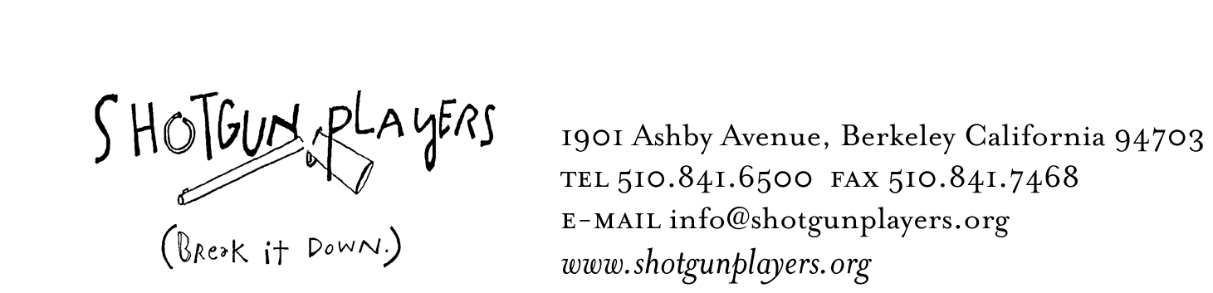

October 10, 2008
FOR IMMEDIATE RELEASE
FOR INFORMATION:
LIZ LISLE at 510-841-6500 x302
SHOTGUN PLAYERS

SHOTGUN PLAYERS PRESENT

Macbeth

BY WILLIAM SHAKESPEARE
DIRECTED BY MARK JACKSON

BERKELEY— Shakespeare’s classic couple are transformed into two young, wealthy, childless hipsters with exceedingly sharp tastes in clothing and insatiable appetites for more of everything. The sex is hot, if always tinged by that faint sense that their questionable fertility leaves them ultimately unable to make a future. Ambitions run amuck, turning to material means of self-definition: money, fashion, fame - and power. Macbeth has never looked so good, danced so hard, or killed with such style. Macbeth opens Saturday, December 6th at 8PM and runs Thursday through Sunday through January 11th at The Ashby Stage in Berkeley.

Macbeth is expected to be grim and overcast, but in this production director Mark Jackson does away with the shadows in favor of bright lights, an architecturally modern stage, and colors from the contemporary pallet. There will be no kilts onstage either, but rather a fashion show runway populated by actors wearing the appropriate couture.

This is a story about ambition, and in today’s America ambition, even political ambition, is tragically caught up in fame, money, and fashions of all kinds. Macbeth and Lady Macbeth are caught in an ugly upper-crust web of frustrated ambition themselves. If children cannot secure their future, then borrowed robes will fashion their present and blood will cement the deal. Fashion show iconography, as well as the appearance of a runway onstage to reflect Shakespeare’s traditional thrust staging will blast the play into the modern sphere.

Macbeth is one of Shakespeare’s most popular plays despite also being quite famously difficult to pull off. The Shotgun production will act as both a wake up call and a surprise—both to entertain and provoke in the way useful theater should. Jackson calls on fashion show aesthetics as a contemporary metaphor through which to view Shakespeare’s once timely, and in its essential aspects still timeless, subjects – ambition and power.
-more-
2-2-2

This is not your mother’s Macbeth. Those interested in roller coasters should stick around.

The cast of Macbeth features Shotgun company members Dan Bruno (Beowulf, Three Musketeers) John Mercer (Blood Wedding, Owners), Reid Davis (Forest War, The Death of Meyerhold) and Zehra Berkman (Cryptogram, Owners) as well as Blythe Foster, Cass Bogatin, Craig Marker, Daniel Duque-Estrada, Daniel Krueger, Jarrod Quon, Kevin Clarke, Peter Ruocco, and Ryan Tasker.

The production will be directed by Mark Jackson, with costumes designed by Valera Coble, and fight choreography created by Dave Maier. Set Design by Nina Ball, Props and Blood Work by Tunuviel Quezada, Light Design by Jon Tracy, Sound Design by Sarah Huddleston. Phil Lowery will stage manage.

CALENDAR LISTING

WHAT: Two young, wealthy, childless hipsters with exceedingly sharp tastes in clothing and insatiable appetites for more of everything. The sex is hot, if always tinged by that faint sense that their questionable fertility leaves them ultimately unable to make a life for themselves. And so their ambitions turn toward more material means of self-definition: money, fashion, fame - and power. Macbeth has never looked so good, danced so hard, or killed with such style.

WHEN: Previews Thursday, December 4 and Friday, December 5. Opens Saturday, December 6. Runs Thursday - Saturday at 8PM. All Sundays at 5PM through January 11. (No Performances 12/25-28)

OPENING NIGHT PARTY – Saturday, December 6th. $30 Includes post-show drinking, food and revelry.

SPECIAL NEW YEAR’S EVE PERFORMANCE AND CELEBRATION – Wednesday, December 31st. $50 Includes champagne and fine deserts after the show.

WHERE: The Ashby Stage, 1901 Ashby Avenue, Berkeley, CA 94703

TICKET PRICES: Pay What You Can - $25. The first week of performances, December 4, 5, 6 & 8 are Pay-What-You-Can in advance and at the door for general seats. For December 8 – January 11, tickets are $18 for Thursdays, $22 for Fridays and Sundays, and $25 for Saturdays. $30 Front Row Runway Seats every night. Reservations for all performances are strongly advised. For every performance there will be tickets released at the door. The waiting list for these tickets begins taking names one hour before the performance.

For more information go to www.shotgunplayers.org or call 510.841.6500

For press photos, please download images from our website, or contact
Liz Lisle at liz@shotgunplayers.org, or (510) 841-6500 x302

